Revising Crime and Punishment Papers
Burke
Guidelines
All students must do the following unless they received an A on their paper:
- Revise the paper using my comments
- Use the word-processing “Track Changes” function when making the revisions. It should look like the diagram below.
- Print and submit the page with all the changes and boxes on it.
If you do not follow these guidelines and make the changes, your grade will drop a full grade; make them, and it automatically goes up.
Papers are due when you return from spring break.
Click this button or find “Track Changes” on the menu.

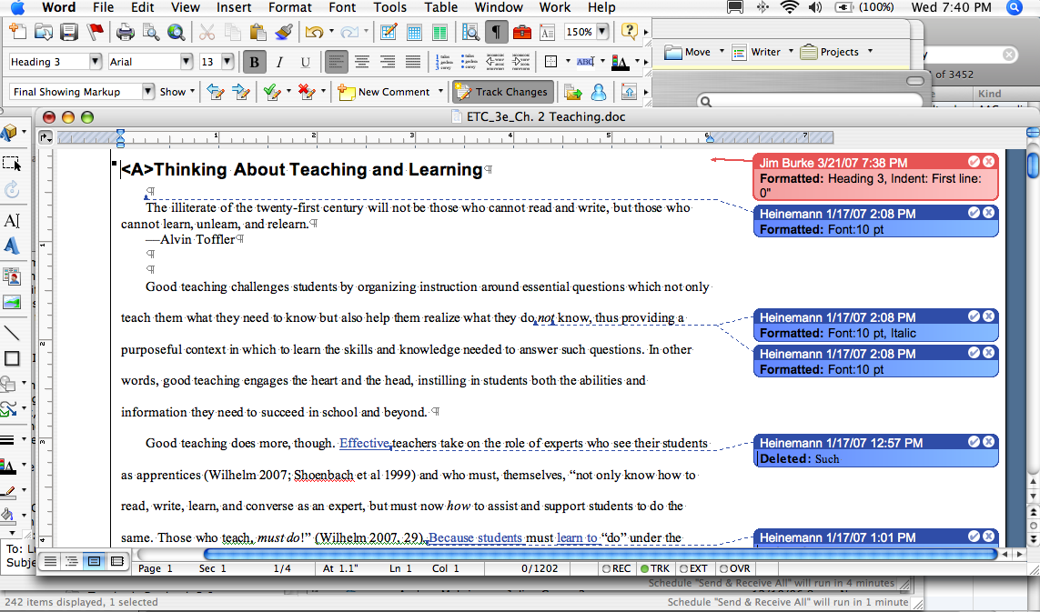

You will know you selected it if you see boxes like this popping up to describe the changes—cuts or additions—you made.

